PROJECT FINAL REPORT
Project ID: 00106724
Reporting Period: February 2019- June 2021

Reporting Period | February 2019 – June 2021
Donor | United States Bureau of Population, Refugees and Migration (USBPRM)
Country | Turkey
Project Title | Effective Urban Waste Management for Host Communities Phase II: Strengthening Social Cohesion through Participatory Waste Management”
Project Locations | Şanlıurfa and Kilis
Project ID  (Atlas Award ID)  Outputs  (Atlas Project ID and Description)  Strategic Plan and/or CPD Outcomes | Project ID: 00105448  Output ID: 00106724,  The project aims to contribute to the social cohesion of Syrians under temporary protection (SuTP) with host communities in the Southeast Anatolia Region
Implementing Partner(s) | Ministry of Environment and Urbanization
Project Start Date | May 2019
Project End Date | June 2021
LPAC Date | 3 July 2018
Steering Committee/Project Board Meeting Dates | 5 December 2020
SDG linkages | SDG 5, SDG 12, SDG 13
GEN marker | GEN2
(Year) Delivery to Budget Ratio | % 99.4
Total resources required | 3,000,000 USD
Revenue received | - Regular USD  - Other  - Donor: 3,000,000 USD  - Trust Fund Cost Sharing USD  - Thematic Trust Fund C/S USD  - Special Activities USD  - EU funding USD  - Total: 3,000,000 USD
Unfunded budget | 0.00 USD
UNDP Contact Person | Sukhrob Khojimatov  Deputy Resident Representative  UNDP Turkey  Email: Sukhrob.khojimatov@undp.org  Tel.: +90 312 454 1162

Executive Summary

The project for “Effective Urban Waste Management for Host Communities Phase II” aims to contribute to the social cohesion of Syrians under temporary protection and host communities through strengthening the resilience of impacted municipalities in targeted areas to better cope with and recover from the impact of the Syria crisis particularly the unprecedent increase in demand for municipal services. The project have done so by supporting the recycling capacities of municipalities and local communities through participatory waste management practices as to improve resource recovery and reduce the negative impact to the local environment and public health.
One of the main expected results of the project was to establish the zero-waste management system in Haliliye (Şanlıurfa) and Kilis Municipalities through identifying the needs of these municipalities and preparation of distinctive roadmaps. Two roadmaps were prepared that includes all the needs and suggestions for the improvement of zero waste management in these municipalities.
The project provided support to the Municipalities of Şanlıurfa and Kilis for the establishment of Civic Amenity Centers which is obligatory for all the municipalities as per the zero waste legislations issued by the Ministry of Environment and Urbanization. Design and construction of both civic amenity centers were completed, and these centers were handed over to the municipalities during the project implementation period.
In line with the project activities, two women’s cooperatives were supported to bring livelihoods options for women through manufacturing products from recyclables. In line with this activity, soap production facility was constructed with the essential machinery and equipment and operationalized to support to women cooperative in Kilis. Supply and installation of vermicompost production line and seedling greenhouse was established to support activities of women cooperative in Şanlıurfa.
The project provided support to municipalities for the establishment of an effective incentive system. Software of the incentive system was designed and prepared, incentive cards were designed and procured, products defined together with the municipalities to be given to the citizens in return of the points that are collected were procured during the project implementation period. An informative animation video that includes information about how the incentive system operates and how the citizens can get involved into this system was prepared.
In line with the awareness raising activity to promote zero waste system, various materials including posters, brochures, animation videos targeting students and all citizens were prepared and also an informative video was prepared and shown on local channels in Şanlıurfa and Kilis to increase the effectiveness of the system.
A Stakeholder Analysis and Social Behavior Assessment study was planned be conducted in order to determine the baseline for the level of awareness on zero waste in targeted cities and to understand the contribution of the Project to the local people and the municipalities. This activity was held for twice during the life of the project; one in the beginning and one before the closure of the Project.

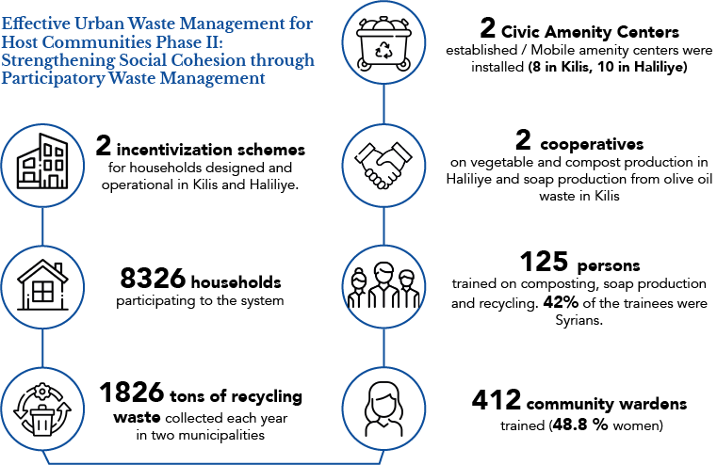

Background Information

Turkey hosts the largest refugee population in the world and has demonstrated strong national ownership of the refugee response. The Government of Turkey provides a rights-based legal framework through the Temporary Protection regulation, which offers access to education, health care, employment and social security to Syrians.
Currently, out of the 3,6 million registered Syrians under Temporary Protection more than 2,6 million Syrians live amongst Turkish host communities. 45% of the 3,2 million Syrians under Temporary Protection are concentrated in 4 provinces in the South East. Within these provinces there are four municipalities in Turkey that are particularly impacted each hosting more than 100,000 Syrians.
In these cities, the ratio of the Syrian population to that of host communities is higher than 15%, including Kilis, Hatay, Gaziantep and Şanlıurfa. Population have either reached or exceeded 2023 population projections. Kilis, for instance, hosts almost as many Syrians as its local population. Therefore, Turkish urban areas are under pressure due to sudden and unexpected population growth. Municipalities, with their already strained capacities, even before the arrival of the displaced Syrians, are trying to cope with the pressure on the basic public service delivery, such as waste, waste management and firefighting capabilities.
UNDP has developed a comprehensive Solid Waste Management Strategy that guides overall support to the Government of Turkey, when responding to the Syria crisis. In line with the Solid Waste Management Strategy, the project gave support tostrengthen the municipal capacities for more efficient and effective waste management services. This was achieved through increasing social cohesion by participatory waste management, creating new and dignified livelihoods opportunities through bringing Syrians and host community members together over common economic and social interests and to increase municipal service delivery capacities of Kilis and Şanlıurfa Haliliye Municipalities.

Progress Review

Output 1: Enhancing livelihoods opportunities and social cohesion improved for Syrians and host communities as a result of skills development in the waste recycling and related sectors and strengthened municipal waste management capacities and reduced operational costs through recycling initiatives

Activity 1: Assessment of district layouts and current routes of transportation and local value chains of solid waste by the municipalities and design and initiation of public awareness campaign to support community driven recycling.

In line with project outputs and activities, firstly technical field visits was conducted together with the Project team, related municipality staffs and the Individual Consultant (IC) that was employed to identify the needs of both Şanlıurfa-Haliliye and Kilis Municipality were conducted between the dates

15-20 July 2019. This technical visit was especially made to the municipalities that has developed zero waste
management system. Five municipalities; İstanbul-Esenler, İstanbul-Beykoz, İzmir-Çiğli, İzmir-Karabağlar and Antalya- Muratpaşa were visited. Good and bad experiences of these municipalities were shared by the representatives. Various topics such as participation of households, usage of outdoor and indoor equipment, waste vehicles, civic amenity centers, mobile civic amenity centers, data and information management, application to collect waste from smart phones were discussed.

After realization of these field visits in July 2019 and conduction of preliminary surveys in August 2019, IC and Project Team worked with each municipality’s related staff to plan the basic needs and to establish Zero Waste System. Data and information, legislation about Zero Waste System was deeply analyzed. Specific needs analysis reports were prepared for both municipalities as a roadmap for the project at the end of September 2019. (Kindly see Annex No:1)
This activity was planned according to the needs analysis reports that were prepared in September 2019 for the municipalities. Current routes and district layouts were identified together with municipality staff, and UNDP and details of these assessments were shared inside the report. According to the needs analysis reports of both municipalities, training and awareness raising activities were planned to be given in both cities in parallel with the awareness raising activities. This activity was planned to be implemented at the beginning of Spring 2020 but cause of the pandemic resulting in restriction about group gatherings, closure of schools, universities and also adaptation of rotational work modality for public offices, this activity has to be shifted to December 2020 together with the trainings about zero waste.

Tender documents were prepared by the project team and tender was published for this activity on 4 March 2020 and closed on 15 April 2020. Normally this tender closing date is firstly mentioned as 25 March 2020, but cause of Covid-19 pandemic, companies requested more time to compile their offers and extension was given until 1 April 2020. Cause of Covid-19, second and third extension was requested from companies again as the situation got worse in Turkey. As a result, UNDP Project team and Procurement Unit discussed this issue and extended the tender closing date till 15 April 2020. Contract was signed with the company and the planning of the activity has been started.

The activity of public awareness raising campaign plan includes (i) promotion of zero waste initiative of the Municipalities by posters, banners, billboards, advertisement videos on local TV channels and outdoor led screens. (ii) distribution of brochures and market bags to households in the selected neighborhoods, (iii) animation videos for students. During the implementation period of this activity, various materials were produced; an informative brochure designed for both Syrians and host community members, market bags aiming to decrease the usage of plastic bags was prepared and distributed to the households, design and rent of billboards completed, design and distribution of banners to increase general public awareness were completed. Four type of posters targeting public institutions, host communities, Syrians, kindergarten, primary, secondary, high school and university students were designed, prepared and posted. Preparation of promotion videos to be shown in the streets to increase the awareness of the citizens were completed and posted, preparation of animation videos that are targeting one for kindergarten and primary school students and one for secondary and high school students were completed and distributed at the beginning of January 2021 and has started to be shown to the students as of February 2021.

As part of zero waste awareness raising campaign, an informative video to increase the awareness of citizens that includes information about what is waste, how to separate waste was prepared and aired on local TV channels, Edessa and GRT TV during the implementation period.

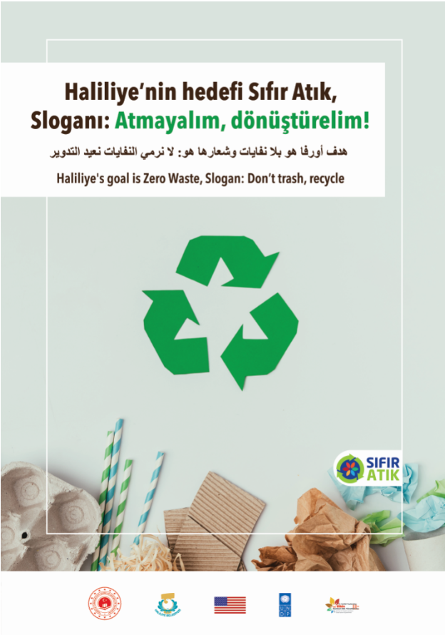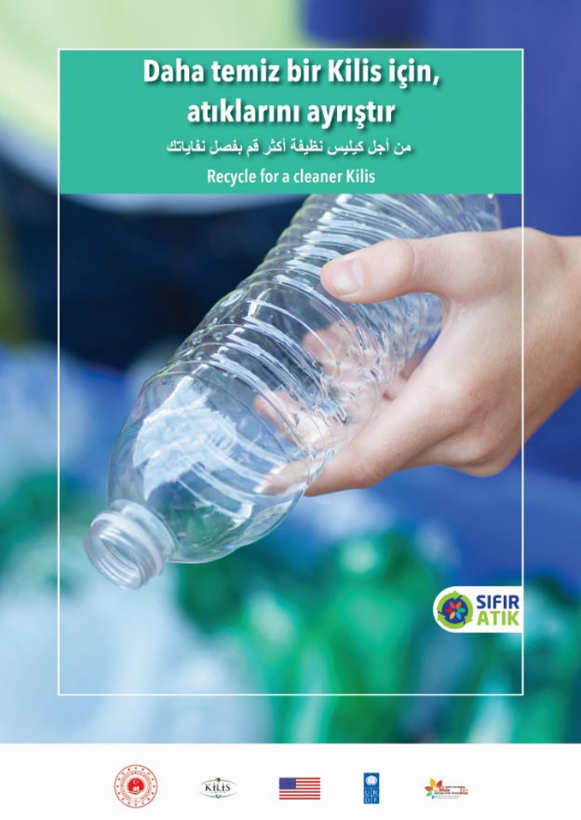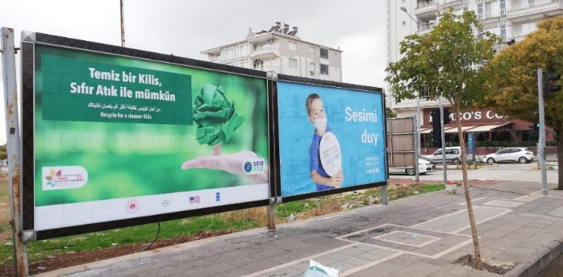
Activity 2: Design and planning of collection and incentivization models, facilitation of private sector participation by the establishment of women’s collectives for handicraft/product manufacturing from recyclables.

An Individual Consultant (IC) has been contracted for the design and planning of collection and incentivization models for the municipalities. Firstly, field visits to the related municipalities has been conducted together with the project team between 5-12 October 2020. Situation analyses of the municipalities have been made where various meetings were conducted with the municipality staff to get the necessary data for the establishment of an effective incentive system. A report reflecting the technical and urgent needs for the establishment of an incentive system was prepared on November 2020 by the IC. (Kindly see Annex No:2) The incentive system software was conceptualized, and development of software was initiated in January 2021 and completed at the end of March 2021 for both of the municipalities. During the implementation period of this activity, essential hardware was procured, incentive cards were designed, printed and distributed to relevant municipalities and integrated to the incentive software system. Software with mobile application was designed and prepared. Procurement of the products defined together with municipalities to be given to the citizens in return of the points that are collected were procured and delivered to the municipalities. An informative animation video about how to use the incentive cards, how the system operates, how to separate the recyclables and how to get the points was prepared and started to be shown to the citizens on the streets and websites of municipalities. The incentive system has been

operational since May 2021 for Kilis Municipality and planned to be made operational at the beginning of May 2021 for Şanlıurfa Haliliye, but cause of the lockdown in Turkey, this activity has to be postponed to June 2021 for Şanlıurfa Haliliye.

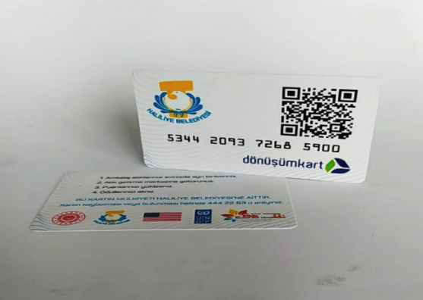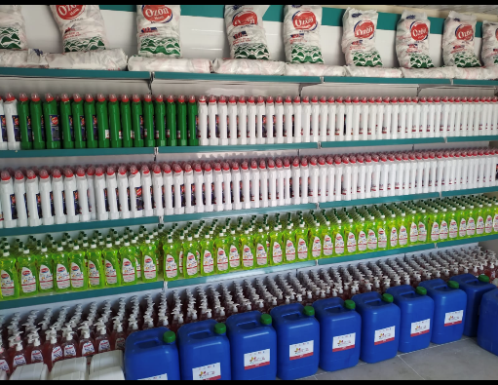

For the supporting of women’s cooperatives activity, that was decided to be implemented in Kilis province, was aimed to increase the added value, profitability, social, environmental and economic benefits of olive pomace. Pomace is a waste of olive oil factories; it is an important biomass variety seen in Mediterranean countries. If it does not have a suitable and acceptable use, it creates environmental problems. Pomace can be considered as an alternative fuel (renewable energy) that do not contain sulfur. Efficient and appropriate use of pomace in energy generation provides solutions to 1) clean energy production, 2) the recovery of this substance, which is the waste of olive oil plants. A very high calorie (4674 kcal / kg) and low ash (1.5%) fuel can be obtained by separating the core in the pomace. The second most important product obtained from pomace is pomace oil used in cosmetics and soap industry. In line with this activity, it was decided to construct the facility that was needed for converting olive oil to be obtained from pomace waste into soap and to procure the needed equipment for the facility to generate a sustainable income by converting olive oil to be obtained from pomace waste into soap (local olive oil soap). through this support, the environmentally damaging pomace waste generated at the facility of the union was processed and the olive oil to be obtained can be processed by the cooperative members and turned into soap. Thus, both the environment is protected and a sustainable facility where women can work intensively was established. Construction of the facility was completed, and the equipment procured as of January 2021. Trainings about the production of hot and cold system olive oil soap, the production of solid soap from pomace oil and olive oil liquid soap production were organized by the project team and conducted through the support of an expert between the dates 15 – 25 February 2021 in Kilis. In total 26 women, including 13 Syrians and 13 host community members completed the trainings.

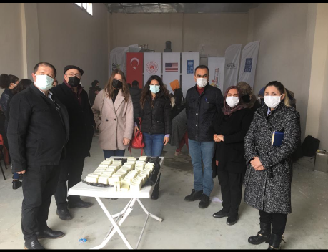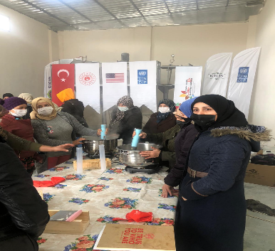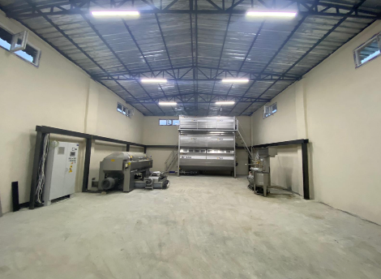

Within the scope of this activity, for Şanlıurfa Cooperative, it was decided to make composting (which is a natural fertilizer used to enrich and regulate the structure of the soil, which is used for growing plants or flowers) that can be possible from organic wastes from 7500 households and 500 restaurants and pruning wastes obtained from parks/gardens.. The compost creates more value addition when mixed with worm, animal manure or liquid fertilizers which yields a more nutritious organic fertilizer which can stimulate local agriculture which provides the largest employment for the Syrians and the host-communities in the project locations. Besides the environmentally friendly disposal and re-use of the oil pomace, the women’s cooperatives can generate more income by producing various seedlings and ornamental plants using these products which significantly reduces their fertilizer cost. Cooperative members are currently growing peppers on an area of ​​15 hectares. It was planned to grow the seedlings of these and similar plants and to grow Geofit (bulbous and tuberous garden plants) and some ornamental plants that Haliliye Municipality needs. The cooperative selling ornamental plants to the municipality. For this purpose, it was planned to build a 1000 m2 high tunnel (stove heated) greenhouse for the Cooperative. By sharing some of the compost and worm manure to be obtained with the Cooperative members, it was planned to support their agricultural production. The municipality can also obtain the ornamental plants it needs. Thus, women who are members of the cooperative was employed in Şanlıurfa and many women was provided with various training and production infrastructure opportunities, and support was provided in social, economic and cultural areas. Regarding the support of women’s cooperative in Şanlıurfa, vermicompost production line seedling greenhouse was supplied and installed during the reporting period. Trainings on vermicompost production seedling cultivation was organised by the project team through support of an expert between the dates 10 – 13 March 2021. In total 25 women, including 11 Syrians and 14 host community members completed the trainings.

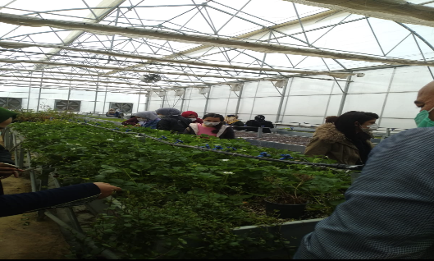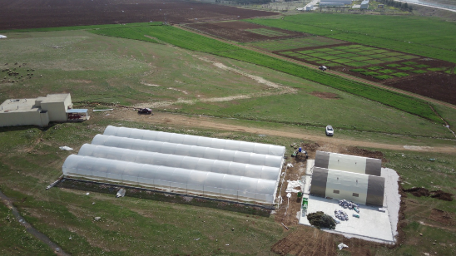

Again, within the scope of our project, trainings on various subjects (women's rights, communication techniques, entrepreneurship, project preparation, production techniques, sales marketing etc.) was given to the members of the cooperative through online platforms.

Activity 3: Support to municipal community centers for the establishment of training workshops and ateliers and implementation of specific skills training programs directed at members of Syrians and host community on recycling operations.

Specific skills trainings on recycling operations about how to make products from waste was organized both in Şanlıurfa and Kilis through the support of an expert. Trainings were given between the dates 8 – 12 February in Kilis and 15 – 19 February in Şanlıurfa. In total, 80 people took the trainings.

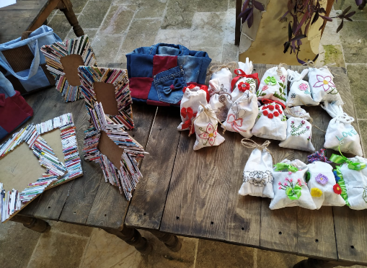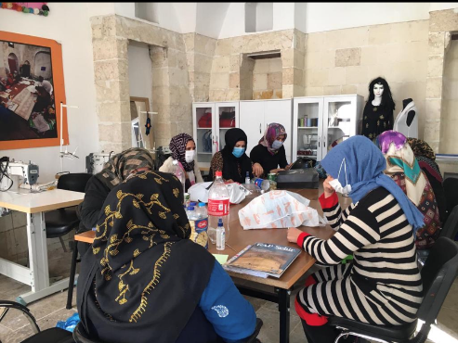

Activity 4: Operationalization of the participatory network with design and initiation of public awareness campaign to support community driven recycling.

This activity was implemented in parallel with zero waste training activity as mentioned in Activity1. Please see Activity 1 for further details.

Activity 5: Provision and installation of supplementing equipment and vehicles to support collection mechanism, including establishing smart waste collection systems.

According to the needs analysis reports of both municipalities, an IC was employed to prepare the technical specifications for the procurement of waste vehicles and supplementing equipment to the related municipalities. Terms of references were prepared together with the other needed tendering documents, tenders were published, and all equipment were procured and delivered to the municipalities during the implementation period of the project.

Procurement of Vehicles

Tender was published on 11 February 2020 and tender was closed on 20 March 2020. Normally, the closing date of this tender was published as 10 March 2020, but due to the Covid-19 pandemic, closure date was extended till 20 March 2020. Contract was signed between UNDP and the company. 3 types of vehicles were delivered to the related municipalities until the end of November 2020.

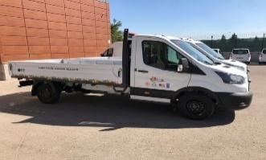
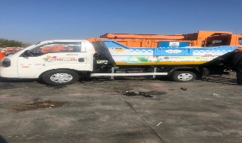
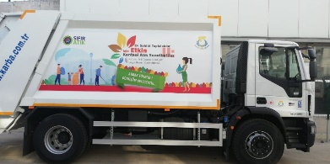

- Procurement of Vegetative Oil Waste and Organic Deposit Equipment

Tender was published on 5 March 2020 and closed on 19 March 2020. Contract was signed between UNDP and company on 7 May 2020. Equipment were delivered to the related municipalities on 10 June 2020.

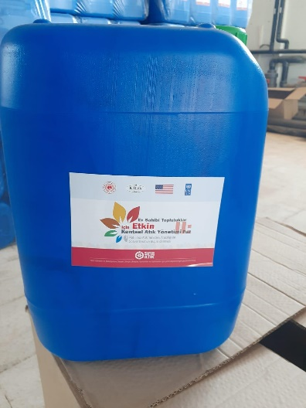
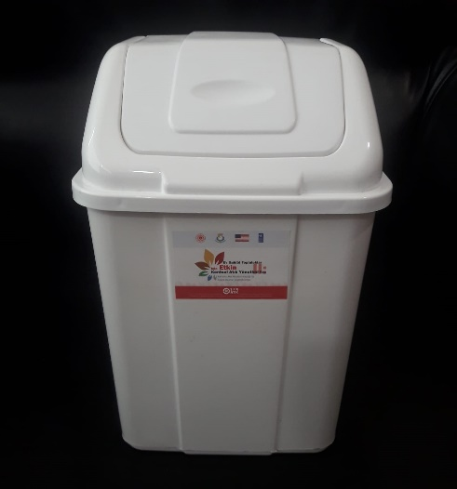
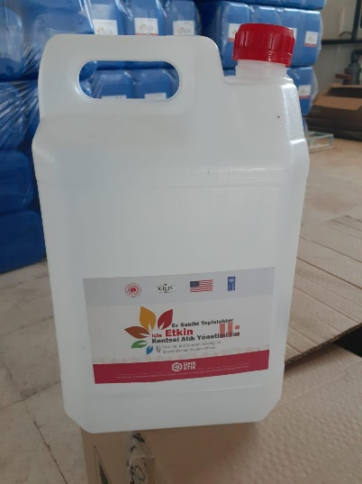

- Procurement of Outdoor and Indoor Equipment

Tender was published on 20 April 2020. Contract was signed between UNDP and the company on 30 June 2020. All equipment was delivered to the related municipalities until the end of November 2020.

Activity 6: Installation of civic amenity center(s) along with containers with sensor arrays and reverse vending automats.

According to the needs analysis reports of both municipalities, an IC was employed to identify the technical specifications needed for the procurement of automat machines and civic amenity centers. Civic Amenity Centers were designed and constructed for each municipality.

Procurement of Automat Machines
Ten automat machines have been procured for Şanlıurfa Haliliye municipality and five for Kilis municipality. All the automat machines have been delivered and placed into the determined streets during the implementation period.

Tender was published on 25 February 2020 and closed on 12 March 2020. Normally, the closure date of this tender was published as 9 March 2020, but cause of request for extension from the companies, closing date was extended till 12 March 2020. Contract was signed between UNDP and company on 29 May 2020. Delivery of these equipment to the related municipalities was completed until the end of August 2020.

Procurement of Mobile Civic Amenity Centers

Ten pieces of mobile civic amenity centers have been procured for Şanlıurfa Haliliye Municipality and eight pieces for Kilis municipality. All of the mobile civic amenity centers were delivered to the related
municipalities. Tender was published on 27 February 2020 and closed on 12 March 2020. These centers were delivered to the related municipalities until the end of October 2020.

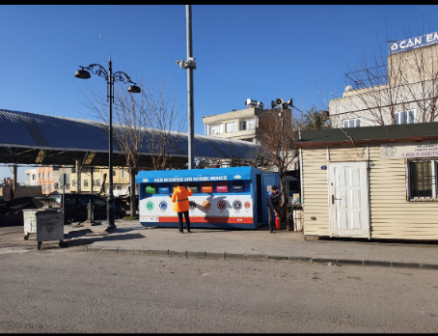

Construction of Two Civic Amenity Centers

Two Civic Amenity Centers, one for Kilis Municipality and one for Şanlıurfa Haliliye Municipality designed and constructed during the project implementation period. Design of the civic amenity centers were completed between the dates 12 February and 30 March 2020. Construction of the centers were completed between the dates 23 October 2020 and 23 February 2021.

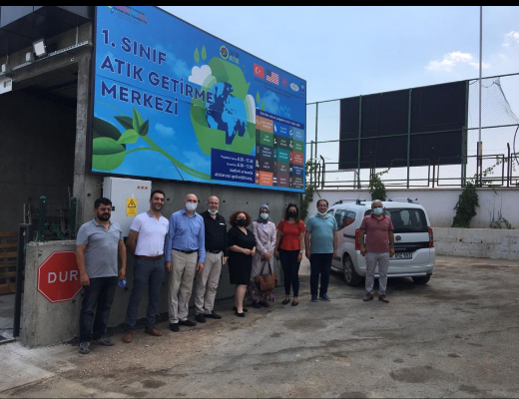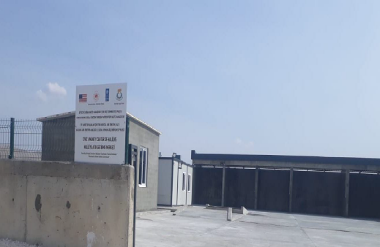

Activity 7: Starting up and facilitating the community warden initiative and linking local licensed recycling companies with participatory source segregation for ensuring sustainability.

Kilis and Haliliye Municipalities contracted licensed companies for the collection and sorting of recyclable waste. This was a part of the protocol signed between the municipalities and the ministry and became an obligation for municipalities. Both of the municipalities completed the process and signed contract with one licensed company for the collection of waste during the project implementation period.

Activity 8: Execution of Stakeholder Analysis and social behavior assessment study & Conduction of surveys

A Stakeholder Analysis and Social Behavior Assessment study was planned be conducted in order to understand the contribution of the Project to the local people and the municipalities. This study was

planned to be provided to better understand the level of awareness about zero waste management in targeted provinces. This activity was held for twice during the life of the project; one in the beginning and one before the closure of the Project.
The processes of this activity has started since November 2019. An IC was employed. The IC realized a visit to Şanlıurfa and Kilis with Project Field Staff between the dates 15-19 November 2019 to measure the awareness and tension about zero waste at the provinces Şanlıurfa Haliliye and Kilis, various stakeholders were visited such as; Municipalities, public education centers, hotels, some of the school representatives, some NGO representatives and Directorate General of Migration Management were visited.
After this visit, the IC has delivered Stakeholder Analysis report to the Project Team on 3rd of January 2020. Conduction of 1st round surveys and in-depth interviews were planned to be implemented between 15-18 March 2020, but due to the Covid-19 pandemic, this activity had to be postponed to July 2020. The IC started conducting 1st round surveys in July 2020. Around 400 surveys have been conducted in Haliliye and Kilis Municipalities.
Second round of surveys was planned to be implemented between the dates 3 – 9 May 2021, but cause of the lockdown in Turkey, this activity has to be postponed to 24 – 30 May 2021 and a report reflecting the impact of the project was prepared at the end of June 2021.
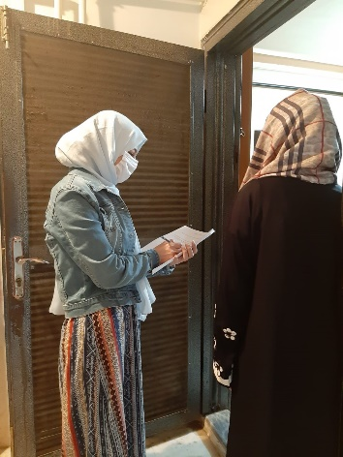

Delays and challenges in the implementation of project activities
The main challenge is the ongoing Covid 19 pandemic for timely and successful completion of project activities. Covid 19 adversely affected the effectiveness of the project activities especially the incentive system and execution of stakeholder analysis and social behavior assessment study that includes surveys and in-depth interviews, trainings and awareness raising activities that includes face to face trainings. In line with the incentive system, there was delay in the execution of incentive system and distribution of incentive cards cause of the lockdown in Turkey. In order to minimize these adverse effects, online meetings were organized with beneficiaries to accelerate distribution of cards and to take appointments more easily for the second-round surveys.

One of the activities of the project has to be suspended two times which is training and awareness raising activity, the target audience of this activity was schools, universities and public staff. As the schools and

universities were temporarily closed at that time of the implementation period, this activity has to be shifted to later stages of the project to take the best affect in terms of increasing the awareness of the citizens in targeted provinces and trainings were organized through online platform for the successfully completion of the activity.

Because of Covid-19, the women's cooperatives and related public institutions and organizations with which we conducted the activity together were either closed or operating at a low level during the pandemic process, so the trainings and the construction work of the facilities has slowly proceed and the remaining activity which is about giving trainings to the cooperatives cannot be done according to the workplan of the project and this activity has to be shifted to later stages.

In consideration of the delayed kick-off and impact of COVID-19 on project implementation, we requested extension from the United States Bureau of Population and Refugee Management (USBPRM) to extend the project completion date from 30 September 2020 to 30 June 2021.

As some of the project activities were delayed in terms of their starting date, it was foreseen that the actual starting date of the activities will take more time. With the extension of time, we had the opportunity to implement these works, which was integrated via exemplary, effectively and efficiently.

Indicator Based Performance Assessment

Indicator | Baseline level | End-of-project target | End-of-project level | Target achievement (%)
1.1 Number of tailor-made initiatives with incentivization schemes for households designed and operational. | 0 | 2 | 2 | 100 %
1.2 Number of participating households. | 0 | 10,000 | 8389 | 84 %
1.3 Number of recyclables collected via source segregation (tons per annum). | 0 | 2,500 | 1,826 | 73 %
1.4 Number of pre-processing equipment along with smart and conventional waste collection equipment including civic amenity centre(s) (minimum three centres are planned to be established; 2 at Kilis and 1 in Şanlıurfa) for recyclable recovery in targeted provinces to handle recyclables collected from the participatory waste projects. | 0 | 3 | 3 | 100 %
1.5 Percentage of savings per ton of solid waste achieved within operations at targeted province and districts.  1.5 (alternative) Percentage of savings per ton of recyclable solid waste – Kilis only | 0% | 20% | 1.2%  31 % | 1.5 (6 %)  1.5 alt (155 %)
1.6 Number women’s collectives established, or existing ones supported to be made operational | 0 | 2 | 2 | 100 %
1.7 Number of individuals enrolled in specific skills trainings on handicraft manufacturing from recycling operations. (At least 50% to be Syrians) | 0 | 200 | 125 | 62.5 %
1.8 Percentage of point to product conversion as a marker for active participation and obtained benefits from incentivization programme. | 0% | 90% | No data | N.A
1.9 Number of volunteer community wardens trained for participatory waste management and environment for every sub district. | 0 | 104 | 412 | 396 %
1.10 Number of positively resulted impact assessments (IAs) on social cohesion by participatory waste management | 0 | 2 | 2 | 0 %

Contribution to Gender Equality

Gender is a key element for this project as waste management at homes are managed mostly by women. Gender marker of the project is GEN2 which means that the project is gender responsive. Despite the project has not been specifically dedicated to gender but issues related to gender have been taken into consideration in all phases of the project. GEN 2 project refer to differentiating needs, status, rights, distribution of benefits of men and women.
In addition to understanding different approaches to and roles of men and women in waste management, one of the main activities of the project wasto support women’s cooperatives which provides livelihood opportunities for women while supporting empowerment of them through basic skills trainings, increasing their awareness on gender equality, expanding their ability of organization and solidarity and facilitating their participation into decision-making mechanisms.
Waste management is a gender related issue and women play a significant role in value chain both as consumers and disposers. Depending on a country or a region, women may have taken place in waste sector as waste collectors, street sweepers, recycling collectors, waste bank operators, junk shop owners or employees and factory workers. As it is well known women have primarily managed household waste. So that for the awareness raising campaign we prepared were gender responsive communication materials to be used in this campaign.
Aligned with meeting realized with cooperatives and their need for various trainings we have contacted KEDV (Foundation for the Support of Women’s Work), which is a women’s organization providing support to women’s cooperatives not only through several trainings but also including them into a broader network facilitating relation among cooperatives and experience-share. On 4 February 2021, representatives from KEDV came together with women to understand needs of from cooperatives in our project to refer them to take part in women’s cooperatives network. Aligned with these meetings a training program was developed by KEDV to increase effectiveness of these cooperatives and to empower women. The trainings were organized via online platforms between the dates 21 and 24 June 2021.

V. Risks and Issues

In line with the activities of the project, possible foreseen risks were defined during the implementation period of the project;

ACTIVITY | RISKS | MITIGATION STRATEGY
Conduction of Training Activity about Zero Waste | This activity was planned to be implemented between September 2020- January 2021 but has to be postponed to June 2020 cause of Covid-19 pandemic. | Online sessions were applied instead of face to face trainings, trainees followed the sessions through online platform. E- learning website was developed for the participants to reach all the training and awareness raising materials produced by the project.
Implementation of the incentive system/ distribution of incentive cards to the households | Slow-down in the distribution of the incentive cards due to lock down in Turkey | Project Team made various online meetings with the beneficiaries to accelerate the process and to discuss the distribution method of the cards.

- Monitoring Arrangements

A field visit has been carried out to Kilis and Şanlıurfa between 10- 14 February 2020 by Syria Crisis Response and Resilience Portfolio (SCRRP) Manager Raged Assi, Monitoring & Evaluation Advisor Serap Öztürk and the project team. Various meetings were held with relevant stakeholders for better coordination of project activities. As a result of the monitoring visit, Project Team suggested to Haliliye Municipality to accelerate the land allocation for the civic amenity center to start the design work not to cause any delays (Kindly See Annex No:9)
Project Steering Committee meeting was held on 15 December 2020 with the participation of USBPRM Senior Humanitarian Coordinator, Department Head of Ministry of Environment and Urbanization, representatives of Strategy and Budget Department and with representatives of UNDP. Completed, ongoing and upcoming activities of the project were discussed. All participants reflected their satisfaction about the project activities according to the current pandemic situation. (Kindly see Annex No:3)
Project Progress meeting was held on 29 March 2021 with the participation of USBPRM and UNDP representatives. Project Progress Meeting was held on 30 March 2021 with the participation of Department Head of Ministry of Environment and Urbanization, and with representatives of UNDP. Completed, ongoing and upcoming activities of the project were discussed. (Kindly see Annex No:4)
A Final Independent Evaluation was carried out between June and September. The purpose of this evaluation was to compare the achievements of the Project against the targets of the output indicators, list findings based on analysis of data, draw conclusions and propose recommendations about actions to take and decisions to make. The audience of the evaluation report are all key stakeholders, including the donor (USBPRM), the national implementing partner (Ministry of Environment and Urbanization) and UNDP. The methodological approach for the evaluation was based on a combination of desk review, data collection and interviews with key stakeholders. Due to COVID-19, no evaluation mission tookplace. The evaluator held in-depth meetings with primary interlocutors as well as a select number of final beneficiaries via zoom. The evaluation report is attached as Annex 10
The recommendations of the Evaluation are as follows:
- The implementation of Zero Waste Markets has proven to be a successful model to engage the population in recycling activities, this should be further expanded. The municipality of Haliliye has expressed its interest in increasing the number of markets, but this will require financial support. USBPM and UNDP should investigate ways to secure funding for the further expansion.
- Interviews with Kilis and Haliliye municipalities confirmed the need for further financing required for the procurement of equipment for waste management. Especially trucks with the capacity of compacting waste (especially paper and cardboard) to reduce the volume are seen as required to manage the huge quantities of waste. USBPM and UNDP supported by the municipalities and the Ministry of Environment and Urbanisation should investigate ways to secure funding for the procurement of equipment.
- The integration of informal waste pickers into a formal system with financial compensation for recyclables collected has solved several issues (transforming an illegal into a legal system, increasing security in neighborhoods, generating income for familiies of waste pickers). This system should be expanded in cooperation between the municipalities and the recycling companies engaged by the municipalities.
- The system of reverse vending automats should be improved by adding the possibility of collecting points with the incentivization cards. This could help in increasing the participation of the population, as the points can be converted into products. The products available can be modified over time, keeping and further increasing the interest of households.
- The training activities focused on mostly on the education sector. While this will give positive effects in the medium- and long-term, it fails to directly reach women and men in target households. The social behavior assessment failed to answer the question on how to best approach target households, whether the project contributed to social cohesion and what additional measures and activities are necessary to increase social cohesion. It is recommended to carry out follow-up surveys focusing on those topics.
- Extensive training activities have been carried out under the Project and there was a focus on Training of Trainers (ToT), so there was a good basic introduction given on recycling. Two points require follow up: 1) Due to the COVID-19 situation, all trainings were held virtually. This clearly reduces the effectiveness of the training as there is less attention of participants, little interaction between trainees, little discussion. A follow-up of training activities through live trainings is recommended to sustain the capacity of trainers. 2) ToT activities focused mostly on educational institutions, which should lead to medium- to long-term effects. Additional training and awareness activities directly focusing on the key target group (women) would help in sustaining the positive effect of the project. The community warden system should be extended, and further potential wardens should receive the required training. Focus in the next phase should be on wardens who will have intensive contact with women and men in the target area. It is important that municipalities take a lead on this initiative, as they are best placed to understand which groups of persons already have contact to households and can transport recycling topics.
- The support of women’s cooperatives has proven successful and has helped in both generating work opportunities for women as well as improving social cohesion. Further initiatives on supporting additional cooperatives should be taken by USBPM and UNDP.
- When expanding the community warden system, special care should be taken that gender equality and women’s empowerment issues are considered as waste segregation at household level is linked with women. Such persons should be selected for the community warden system which can establish good contacts to women.

Lessons Learned

- The project has been designed within a timeframe of 18 months, however, for the Projects focusing on waste management, a longer implementation period would have allowed to measure and monitor the short and medium-term impacts of the project and to clearly see the outputs of the project.
- The sub- activities of the project should be initially designed to better plan the activities, a detailed workplan of the activities and sub-activities should be integrated to the project document as strong efforts were made to coordinate and make the required linkages between the activities for the successfully completion of the project.
- The collaboration between local government institutions has a great potential to increase the effectiveness and impacts of the Projects
- In the absence of municipal capacity in data collection, reporting on actual achievements such as Percentage of savings per ton of solid waste achieved” or “Percentage of point to product conversion as a marker for active participation to incentivization programme” becomes difficult to track and report. Municipal capacity for generation of reliable waste statistics is key to demonstrate the viability of community-based recycling initiatives in the long run. More capacity building activities for municipalities should be designed and executed from the beginning of such projects so that municipalities can generate such statistics in the long run.
- Community recycling initiatives are undertaken in a copy-paste manner without considering whether their Theory of Change (ToC) is robust and whether such initiatives do pay off. One clear assumption of this project was that community-based recycling is possible via awareness raising plus an incentive system to make it more appealing. However, a discussion with Kilis Municipality reveals that it is the previous 200 informal waste pickers (now formally recognized by the municipality with their vests and continuing this task under a more recognized formal arrangement) who are bringing the most to Civic Amenity Centers in return for cash (and not necessarily requesting products). While the intervention is supposed to be a community-based initiative, it seems it is still more relevant for informal waste pickers. As long as informal waste pickers are treated in a right-based manner, they may be more efficient than a full-scale community initiative and ToCs of future projects should be based on extensive field work to claim the contrary.
- Training and awareness raising programs reach critical number of SuTPs and host communities, but their effects remain largely unknown. Impact assessments should be more rigorous and carefully planned ahead of the activities. Quality of consultants is key in that regard. Sampling size, profile of the sample should be more carefully planned and executed to get reliable estimates of impact. If awareness raising activities are not meaningfully reaching the total population of pilot cities, IAs should only be executed with the segments that were properly targeted by trainings.

Conclusions and Way Forward

Community-based participatory waste management can be replaced in the context of climate inducted migration and there have been talks between Syria Crisis Response and Resilience Portfolio (SCRRP) and Climate Change and Environment (CCE) portfolios, particularly about considering implementation of community-based participatory waste management within a prospective GEF-funded project which will be implemented in Jordan and Turkey. The community-based participatory waste management projects are sustainable by default as the municipalities take over the equipment and facilities provided with a pledge to continuing the activities. Similar community-based participatory waste management activities can be replicated in other municipalities which are hosting large number of refugees and are prone to climate inducted migration both cross-border and internally. Therefore, expanding the community-based participatory waste management activities in Haliliye to the entire Sanliurfa province would be a natural expansion as a next step.
However, regarding the donor of this Project, the waste Management activities will likely not continue as PRM’s focus is on humanitarian activities and any development intervention from their perspective has to have a humanitarian aspect to it such as livelihoods and social cohesion. PRM tries to fill the funding gaps in areas which are under-funded, and this regards waste management is not a priority as EU invests large sums in this area, hence UNDP proposes to continue partnership with PRM in livelihoods and social cohesion activities. The focus for future partnership would be:
- Scaling up and expanding the livelihood components of previous PRM funded projects on supporting women cooperatives
- Focusing on Digital Livelihoods, Agricultural Development, and Social Cohesion & Protection
- Targeting the most vulnerable refugee women (Syrian, Afghan, Iraqi and other)
UNDP received demand from Hatay and Akçakale/Şanlıurfa municipalities in support of women cooperatives which UNDP proposes to address by:
- Supporting 400 local women - refugee and host community member - in building technical skills for production, income generation, marketing, and life skills such as communication, financial literacy, and language
- safe environment for women for resilience building and enhancing social cohesion through psychosocial support and social events
- Establishing, supporting and facilitating integration of new and/or existing women cooperatives to national, regional and global markets

Financial Status
The below Figure represents the status of the project budget, expenses as of June 2021. In total the total expense of the project budget is 2,984,333.56 USD out of 3,000,000.00 USD.

Annexes
Annex 1: Roadmaps of Municipalities
Annex 2: Report reflecting the needs of municipalities for Incentive System
Annex 3: Steering Committee Meeting Minutes
Annex:4: Progress Meeting Minutes
Annex 5: Awareness Raising Produced Materials
Annex 6: Awareness Raising Campaign Plan
Annex 7: Training and Awareness Raising Activity Final Report
Annex 8: Report of the Cooperative Trainings
Annex 9: Monitoring Mission Report
Annex 10: Final Independent Evaluation Report

Official data Directorate General for Migration Management, Turkey, July 2020.
Republic of Turkey – Ministry of Interior Directorate General of Migration Management, Statistics – February 2019.
This indicator is calculated by dividing the total recycled waste to total solid waste. However, comparing recycled amount to total waste is not doing justice to this project since not all waste can be recycled, and it is a flawed and misleading indicator when total solid waste is used as the denominator. According to Solid Waste Characterization Report (2021) of Kilis Province, potentially recyclables are approximately 38% of total waste, which can be partially considered to be suitable for processing for recycling. If we take only the recycled waste as a proportion of potentially recyclable waste, we will arrive at a more reliable estimate of project impact. We calculated this amount for Kilis and it is 31 % of total waste and beyond the project target of 20 %
Percentage of point to product conversion as a marker for active participation and obtained benefits from the incentivization programme, it is difficult to collect this data from the municipalities as both of the municipalities implemented two types of systems, one of the system is giving products to the citiziens according to the points that are collected in their incentive cards, the second system is the one which most of the citizens prefer taking money from the municipalities according to the waste that are collected, so it is difficult to collect this data from the municiplaities.
While a baseline and follow up surveys were completed, these IAs are not reliable in the sense that the sample size (around 250 persons per city) are not big enough to claim enough representation of Syrian and host community populations. A reliable sample size would have been 2000 per city (1000 Syrians, 1000 HC) meaning 4000 respondents for each round. The profiles of respondents also vary too much in each round to claim the baseline and follow up surveys are targeting identical people. The IA also did not try to reach people who were part of awareness raising activities of this Project but general population. A Project with limited resources cannot change perceptions, attitudes and behaviours of an entire city but only those respondents who were part of trainings, so the assumptions of the IA are also flawed in that sense.
According to Kilis Municipality, around 1500 recycling material is being collected via the system established while 1000 kg is collected by illegal waste pickers, totaling 2500 kg per day (the waste collected by Civic Amenity Centers per day). This means 200 Syrian waste pickers who are recognized by Kilis Municipality bring 40 % of total recycling material in a given day.

